SIMATS ENGINEERING

ASSESSMENT TOOL1

Name :Varshitha Mahadevan
Reg.no.:192511147

COURSE NAME: Artificial Intelligence COURSE CODE: CSA17

COURSE OUTCOME COVERED

CO2: Experiment search and game-solving techniques such as Greedy Search, A*, CSP, Minimax,andAlpha-BetapruningwithheuristicfunctionsforsolvingcomplexAI problems efficiently. (BL3)

AssessmentToolWeightage:40%

Duration: 1 Hour
QUESTIONS: 3 TotalMarks:30

Annexure A

Application Based Questions

Code of Conduct:

I Varshitha Mahadevan (Name / Reg No) certify that this submission is my original work and that I have adhered to the guidelines specified for this assessment.
I understand that any violation of academic integrity rules will result in disciplinary action.

Signature of the student:

Annexure A

Application Based Questions
- IntelligentRoutePlanningusing A*andGreedy Search.
Asmartdeliverysystemisdesignedtotransportmedicalsuppliesbetweencities.Thesystem uses informed search strategies to determine optimal routes.
The road network is given below:
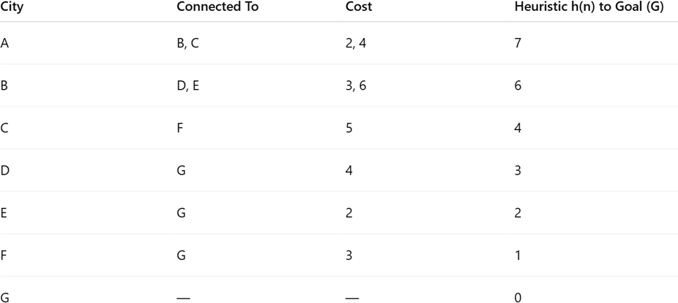

Tasks:
  - ConstructthesearchtreefromAtoG.
  - ApplyGreedyBest-FirstSearchandshownodeexpansionorder.
  - Apply A* algorithm using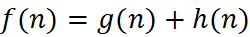.
  - Justifywhichalgorithm isbetter forreal-time emergencydelivery systems.

ConstraintSatisfactionProblem–UniversityTimetableScheduling
A university mustschedulefinalexamsfor5subjects:AI,ML,DBMS,OS,CNacross3days (Day 1, Day 2, Day 3) with the conditions, AI and MLcannotbescheduledonthesameday, DBMS must be scheduled before OS, CN cannot be on Day 1, At most 2 exams per day, A student is enrolled in AI, DBMS, and CN → these cannot overlap

Tasks:
  - Formulate this problem as a Constraint Satisfaction Problem (CSP) by defining,
Variables,DomainsandConstraints
  - Draw the constraint graph.
  - Solve using Backtracking Search.
  - ApplyForwardCheckingorArcConsistencyandexplainhowitreducesthesearch space.

  - Provide one valid timetable solution.

Game Playing – Minimax and Alpha-Beta Pruning
An AI agent is designed to play a turn-based strategy game. The game tree is given below:
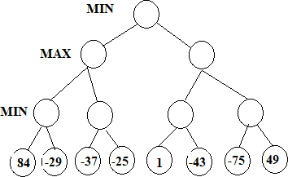

Tasks:
  - Apply the Minimax algorithm and compute values for all internal nodes.
  - Identify the optimal move for MAX.
  - ApplyAlpha-BetaPruningtoShowαandβvaluesateachstepandClearlyindicate which nodes are pruned
  - Compare nodes evaluated in Minimax vs Alpha-Beta
  - Explain the importance of evaluation functions in complex games like chess.

1. Given Data
City | Connected To | Cost | Heuristic h(n)
A | B, C | 2, 4 | 7
B | D, E | 3, 6 | 6
C | F | 5 | 4
D | G | 4 | 3
E | G | 2 | 2
F | G | 3 | 1
G | – | – | 0

i) Construct the Search Tree from A to G
A
/ \
B(2) C(4)
/ \ \
D(3) E(6) F(5)
| | |
G(4) G(2) G(3)

ii) Apply Greedy Best-First Search
Greedy Search selects the node with the smallest heuristic value h(n).

Heuristic Values
Node | h(n)
A | 7
B | 6
C | 4
D | 3
E | 2
F | 1
G | 0

Node Expansion Order
A → C → F → G

Path Found
A → C → F → G

Total Cost
= A→C + C→F + F→G
= 4 + 5 + 3
= 12
iii) Apply A Algorithm ( f(n) = g(n) + h(n) )*

Step 1
Start Node
Node | g(n) | h(n) | f(n)
A | 0 | 7 | 7
Expand A

Step 2
Node | g(n) | h(n) | f(n)
B | 2 | 6 | 8
C | 4 | 4 | 8
Choose B (tie).

Step 3
After expanding B
Node | g(n) | h(n) | f(n)
D | 5 | 3 | 8
E | 8 | 2 | 10
C | 4 | 4 | 8
Choose C.

Step 4
After expanding C
Node | g(n) | h(n) | f(n)
D | 5 | 3 | 8
F | 9 | 1 | 10
E | 8 | 2 | 10
Choose D.

Step 5
After expanding D
Node | g(n) | h(n) | f(n)
G | 9 | 0 | 9
E | 8 | 2 | 10
F | 9 | 1 | 10
Goal node G is reached.

Optimal Path
A → B → D → G

Total Cost
= A→B + B→D + D→G
= 2 + 3 + 4
= 9
iv)Reason:
- Finds the optimal (shortest) path.
- Uses both actual cost (g) and heuristic value (h).
- More accurate and reliable than Greedy Search.
- Suitable for real-time emergency delivery systems where the shortest route is important.

Final Answer
Algorithm | Path | Cost
Greedy Best-First Search | A → C → F → G | 12
A* Search | A → B → D → G | 9

Conclusion
A* is the better algorithm because it finds the optimal path with the minimum cost (9), making it more suitable for real-time emergency delivery systems.

2. Problem Statement
Schedule the final exams for AI, ML, DBMS, OS, and CN across 3 days (Day 1, Day 2, Day 3) with the following constraints:
- AI and ML cannot be scheduled on the same day.
- DBMS must be scheduled before OS.
- CN cannot be scheduled on Day 1.
- At most 2 exams per day.
- A student is enrolled in AI, DBMS, and CN, so these exams cannot overlap.
i) Formulate the Problem as a CSP

Variables
X = {AI, ML, DBMS, OS, CN}

Domain
D = {Day 1, Day 2, Day 3}
Each subject can be assigned to any one of the three days.

Constraints
- AI ≠ ML
- DBMS < OS (DBMS must be before OS)
- CN ≠ Day 1
- Maximum 2 exams per day
- AI ≠ DBMS
- AI ≠ CN
- DBMS ≠ CN
ii) Draw the Constraint Graph
AI -------- ML
| \
| \
DBMS --- CN
|
|
OS
Edges represent constraints between subjects.
iii) Solve using Backtracking Search

Step 1
Assign AI = Day 1

Step 2
ML cannot be Day 1.
Assign ML = Day 2

Step 3
Assign DBMS = Day 1
(DBMS is before OS.)

Step 4
CN cannot be Day 1.
Assign CN = Day 3

Step 5
OS must be after DBMS.
Assign OS = Day 2
No constraints are violated.
iv) Apply Forward Checking / Arc Consistency

Forward Checking
After assigning a subject, remove invalid days from the remaining subjects.
Example:
- AI = Day 1 → Remove Day 1 from ML.
- DBMS = Day 1 → OS can only be Day 2 or Day 3.
- CN cannot be Day 1.
This reduces unnecessary searches.

Arc Consistency
Arc Consistency removes inconsistent values from the domains before searching.
It ensures that every assignment satisfies all constraints and reduces the search space.
v) One Valid Timetable Solution
Day | Subjects
Day 1 | AI, DBMS
Day 2 | ML, OS
Day 3 | CN

Final Timetable
Subject | Scheduled Day
AI | Day 1
DBMS | Day 1
ML | Day 2
OS | Day 2
CN | Day 3

3.Given Leaf Node Values
84, -29, -37, -25, 1, -43, -75, 49
Root = MIN
Level 1 = MAX
Level 2 = MIN

i) Apply the Minimax Algorithm

Step 1: Evaluate MIN Nodes
- MIN(84, -29) = -29
- MIN(-37, -25) = -37
- MIN(1, -43) = -43
- MIN(-75, 49) = -75

Step 2: Evaluate MAX Nodes
- MAX(-29, -37) = -29
- MAX(-43, -75) = -43

Step 3: Evaluate Root (MIN)
- MIN(-29, -43) = -43

Internal Node Values
Node |  | Value
MIN(84, -29) |  | -29
MIN(-37, -25) |  | -37
MIN(1, -43) |  | -43
MIN(-75, 49) |  | -75
MAX(-29, -37) |  | -29
MAX(-43, -75) |  | -43
Root (MIN) |  | -43

ii) Optimal Move for MAX
The MAX player chooses the branch with the highest value.
Left MAX = -29
Right MAX = -43
Since -29 > -43, MAX chooses the left branch.
Optimal Move for MAX = Left Branch (Value = -29)

iii) Apply Alpha-Beta Pruning

Initial Values
α = -∞
β = +∞

Left Subtree
- MIN(84, -29) = -29
- MIN(-37, -25) = -37
- MAX = -29
Root β = -29

Right Subtree
- MIN(1, -43) = -43
Since -43 ≤ β (-29),
the remaining subtree (-75, 49) is pruned.

Pruned Nodes
-75 and 49

iv) Compare Minimax and Alpha-Beta
Minimax | Alpha-Beta Pruning
Evaluates all nodes | Prunes unnecessary nodes
More computations | Faster search
Slower | More efficient
Best for small trees | Best for large game trees

v) Importance of Evaluation Function
- Estimates the quality of a game position.
- Helps choose the best move when the search cannot reach the end of the game.
- Reduces computation time.
- Improves decision-making in complex games like Chess.
- Makes AI play more intelligently.

Final Answer
- Root Value (MIN) = -43
- Optimal Move for MAX = Left Branch
- Pruned Nodes = -75 and 49
- Alpha-Beta is more efficient than Minimax because it avoids evaluating unnecessary nodes.

RUBRICS FOR CALCULATION

Criteria | Weightage | Level 4 – Exemplary | Level 3 – Proficient | Level 2 – Developing | Level 1 – Beginning
Understanding of Problem  Context | 20 | Clearly understand s the  problem and  accurately identifiesall requiremen ts | Good  understandin g with minor gaps | Basic  understanding; some  requirements unclear | Poor understandi ng or  misinterpret ation of the problem
Applicationof Concepts | 30 | Accurately applies  appropriate concepts to solve  complex problems | Applies relevant concepts  correctlywith minor errors | Applies basic concepts with  limitedaccuracy | Failstoapply appropriate concepts
Problem-Solvi ng Approach | 20 | Logical, well-structu red, and  efficient approach | Mostly logical approachwith minor gaps | Basicapproach with some  inconsistencies | Illogicalor unclear  approach
Accuracyof Solution | 20 | Completely correct  solution withproper justification | Mostlycorrect with minor  errors | Partiallycorrect solution | Incorrector incomplete solution
Clarity | 10 | Clear,  well-organi zed, and  properly explained solution | Understandab le with minor clarity issues | Limited clarity andexplanation | Poorly presented  anddifficult to understand

